BLC - IDEAS FOR BRAILLE READING

Reinforcing the naming and fingering of the six dots,
- Tennis ball match-up.
- Fill 2 6-space muffin tins with tennis balls (or 2 half egg cartons with ping pong balls)
- Take turns making mystery letters for each other.
You make letter ‘e’ – dots 2/5 and your partner has to name the dots and the letter (in either order)…. If they can’t do this, then give the information and reinforce this letter a few turns later.
- Your partner creates a letter. If it is a nonsense letter, then tell them…. And ask that they try again or tell you the letter and you will fix the balls for them to name the letter.
- When taking turns with this game, reinforce the letter sounds (especially vowels) … add on by having to name 3 things that begin with the letter sound.
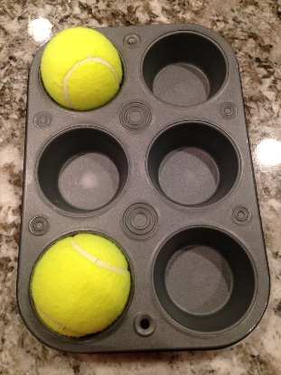
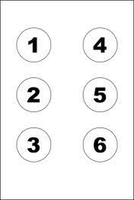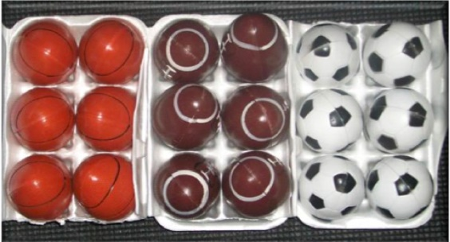

This same strategy can be used for all braille character reinforcement, individual letters and contractions…. It’s a game, have fun!
- Braille cell numbers can also be practice by playing,
“I’m Thinking Of…”
- Play this game with the family… “I thinking of dots 1-3, can you name my letter”. Take turns, if you guess wrong, the turn goes to the next person.
- Extend this game by learning to spell simple word. Child starts with ‘e’, you add ‘g’, sister adds ‘g’.

Reading with your child.
- Tracking is important, but boring!
- Start with your child riding on your hands, then you get to ride on their hands. Alternate pages, or lines…depending on the amount of braille on the page. Single lined pages are easiest for your child to read.
- Often the tracking will not match the words when reading repeated line text, found in the home readers. IT IS OKAY if your child has memorized the repeated lines, but to reinforce the actual match up of words with fingers, ask the child to go back and find a specific word… or find the 4th word in the line, or find the word that starts with a specific letter.
Foods can be cold. (find the word – can, or find the word that starts with b, or find the 4th word).
- Letter-Word search - Reinforce by MATCHING
- Give the child the information you want them to learn, tell them what it is – their job simply involves matching from cards or a list that is produced in a random order.
- Commercial card games can be ‘brailled – up’ to give more variety – use memory games, or cards.
- Find the page numbers.
- Dice Games for numbers
- Use a cookie tin and magnetic counters.
- Partition the tin with a strip of masking tape, so that there is line to move the counters over…
- Make it a game by taking turns… extend this game by finding the brailled numbers on a braille sheet.
- Practice numbers and letter order with DOT-TO-DOT.
- Adapt a simple dot-to-dot page with braille numbers and join the dots with a felt pen or wikki-stix

Commercial games – brailled – can be purchase from the Braille Super Store – http://www.braillebookstore.com/Toys-and-Games

Check out online resources such as https://braillebug.org
http://braillebug.afb.org/games.asp
Or resources for many different topics at https://www.pathstoliteracy.org

